Hardware Hack Lab
Stuff that sits in the Hardware Hack Lab Barcelona.

NodeMCU + Range Sensor
A NodeMCU (ESP8266) connected to a range sensor (HC-SR04)
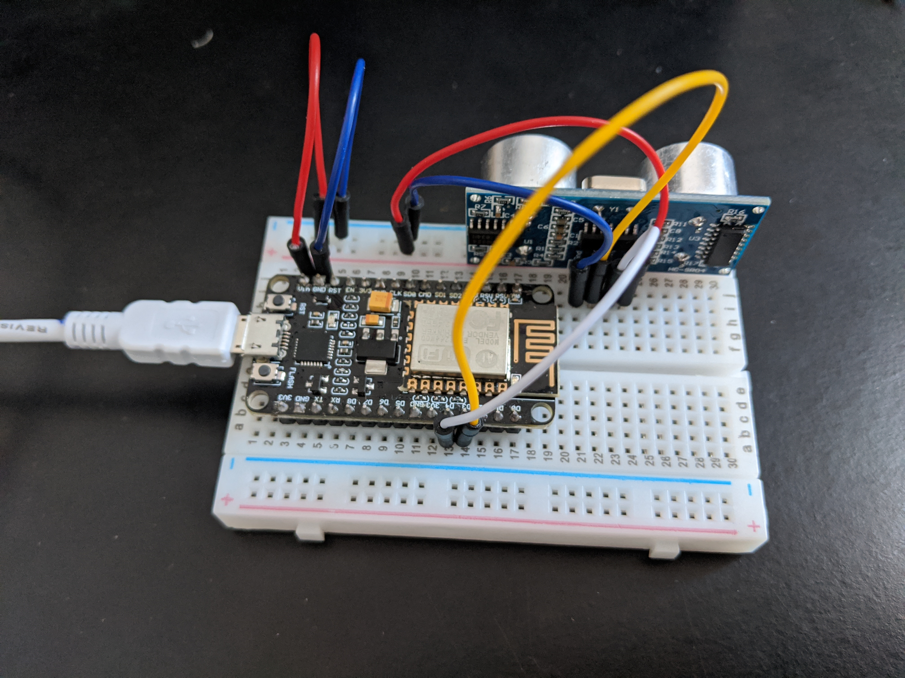 NodeMCU on a breadboard connected to a range Sensor
Here are the two tutorials that got me this circuit wired properly:
- Using the HC-SR04 Ultrasonic Distance Sensor with Arduino
- GPIO map for NodeMCU
The key difference with these tutorials and other tutorials found online explaining the same process:
- The GPIO pins are differently ordered on an ESP6288 than on an Arduino.
- Most tutorials with the ESP8266 and HC-SR04 tell you to connect the sensor to 3.3V output from the NodeMCU board, but that did not work at all for me. Connecting to the Vin output port worked because it delivers 5V or close.
Here is the functioning code I used (it requires installation of NewPing library in Arduino IDE):
/*
HC-SR04 Basic Demonstration
HC-SR04-Basic-Demo.ino
Demonstrates functions of HC-SR04 Ultrasonic Range Finder
Displays results on Serial Monitor
Details: https://dronebotworkshop.com/hc-sr04-ultrasonic-distance-sensor-arduino/
GPIO map for NodeMCU: https://nodemcu.readthedocs.io/en/master/modules/gpio/
*/
// Include NewPing Library
#include <NewPing.h>
#define trigPin 2
#define echoPin 0
#define MAX_DISTANCE 400
NewPing sonar(trigPin, echoPin, MAX_DISTANCE);
float duration, distance;
int iterations = 5;
void setup() {
Serial.begin (9600);
}
void loop() {
duration = sonar.ping_median(iterations);
// Determine distance from duration
// Use 343 metres per second as speed of sound
distance = (duration / 2) * 0.0343;
// Send results to Serial Monitor
Serial.print("Distance = ");
if (distance >= 400 || distance <= 2) {
Serial.println("Out of range");
}
else {
Serial.print(distance);
Serial.println(" cm");
delay(500);
}
delay(500);
}

