Rehogar 2013
Filling the form for the open call for Rehogar 2013
Te presentas como: Individual
Nombre y Apellidos *: Julien Deswaef
Grupo o colectivo:
Email *:
Web: http://xuv.be
Teléfono de contacto *:
Lugar de residencia (ciudad/país) *: Bruselas, Belgica

Breve memoria o trayectoria (máx. 20 líneas):
Julien Deswaef is a designer working in the fields of the web, live video and free culture. He graduated from computer graphic design in ESA, Saint-Luc Brussels in 2000 and then worked for video post-production companies. He also has been veejaying for more than 10 years with Requiem4tv and The Metahub. Using free software as an ethical and practical choice, his works usually involve coding and range from web design to product design, video installations and illustrations. He has also some teaching experience in drawing and computer graphics in different art schools in Brussels.

Propuesta:
Título propuesta*: uHbench

Descripción de la propuesta*:
The uHbench is an open source public bench made out of a standard EPAL-EUR pallet. With little tools and in just a couple of easy steps, you'll be able to turn a wooden pallet into a bench without dismounting completely the pallet and by reusing almost all of its components. The design has been released under CC-by-sa lincense and has been build many times in places around Belgium, France and Spain already.
Imágenes de la propuesta (máximo 3, 2MB cada una) *: 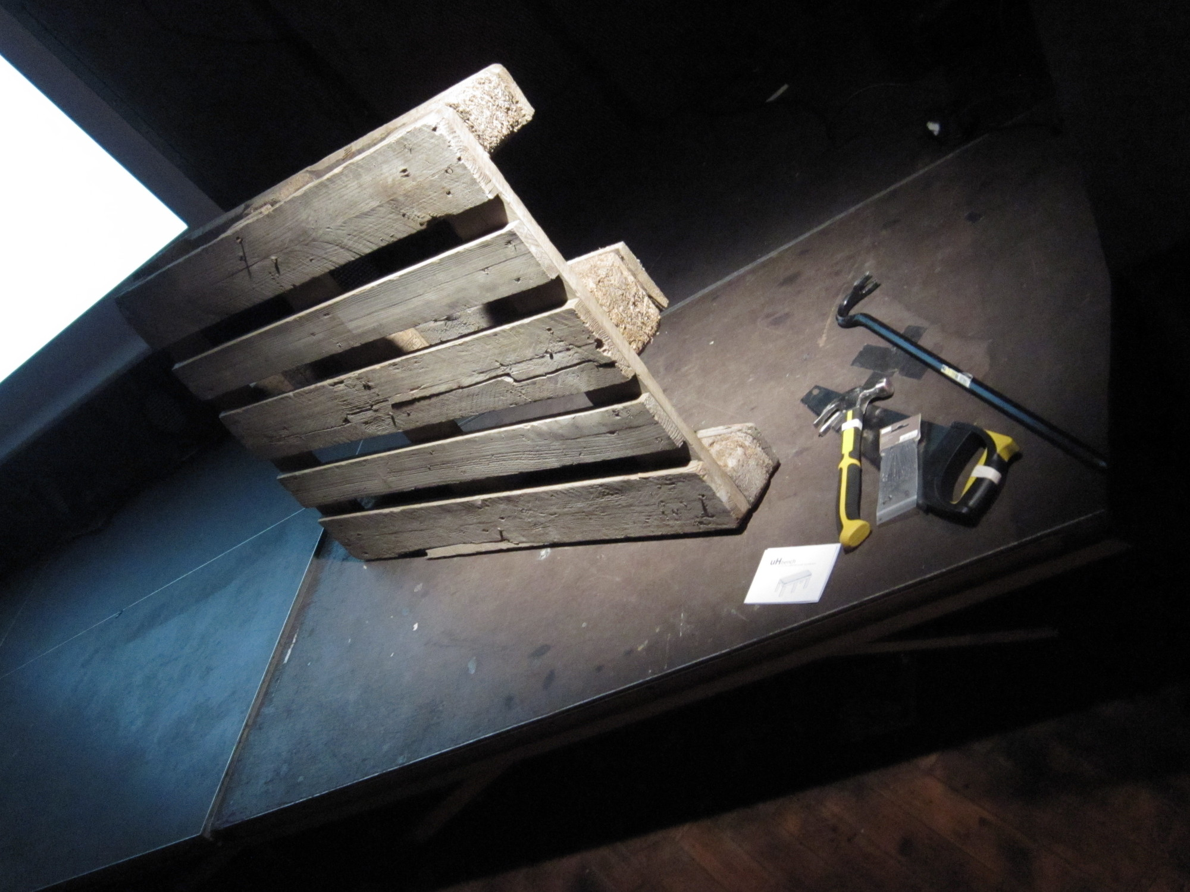 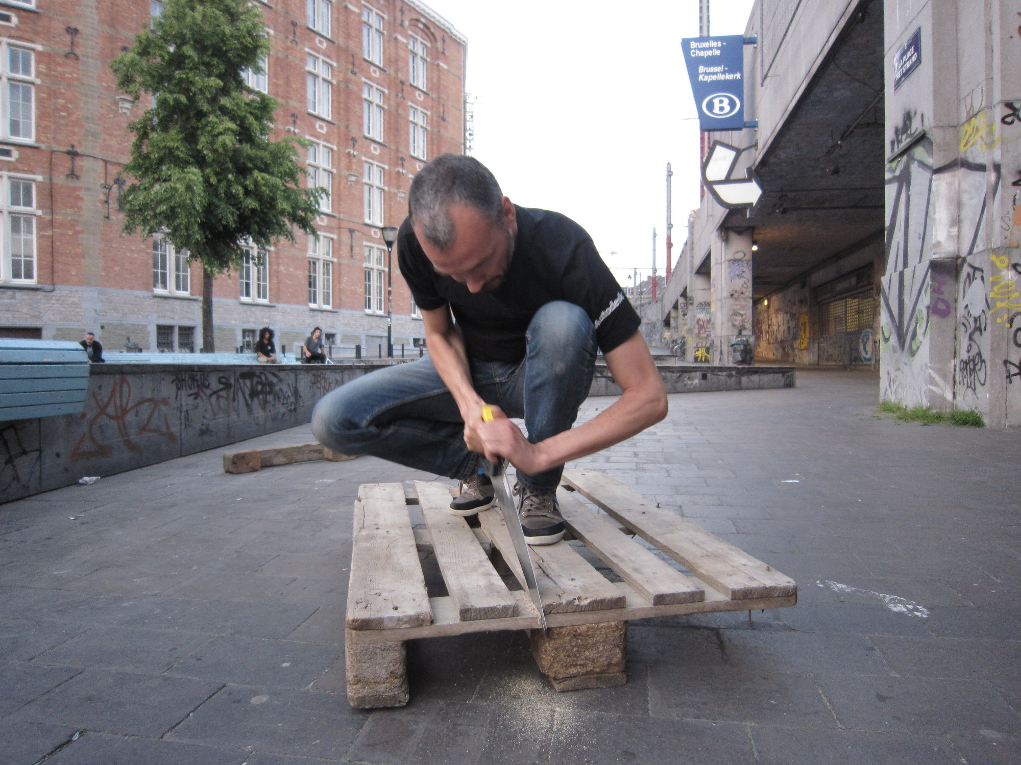 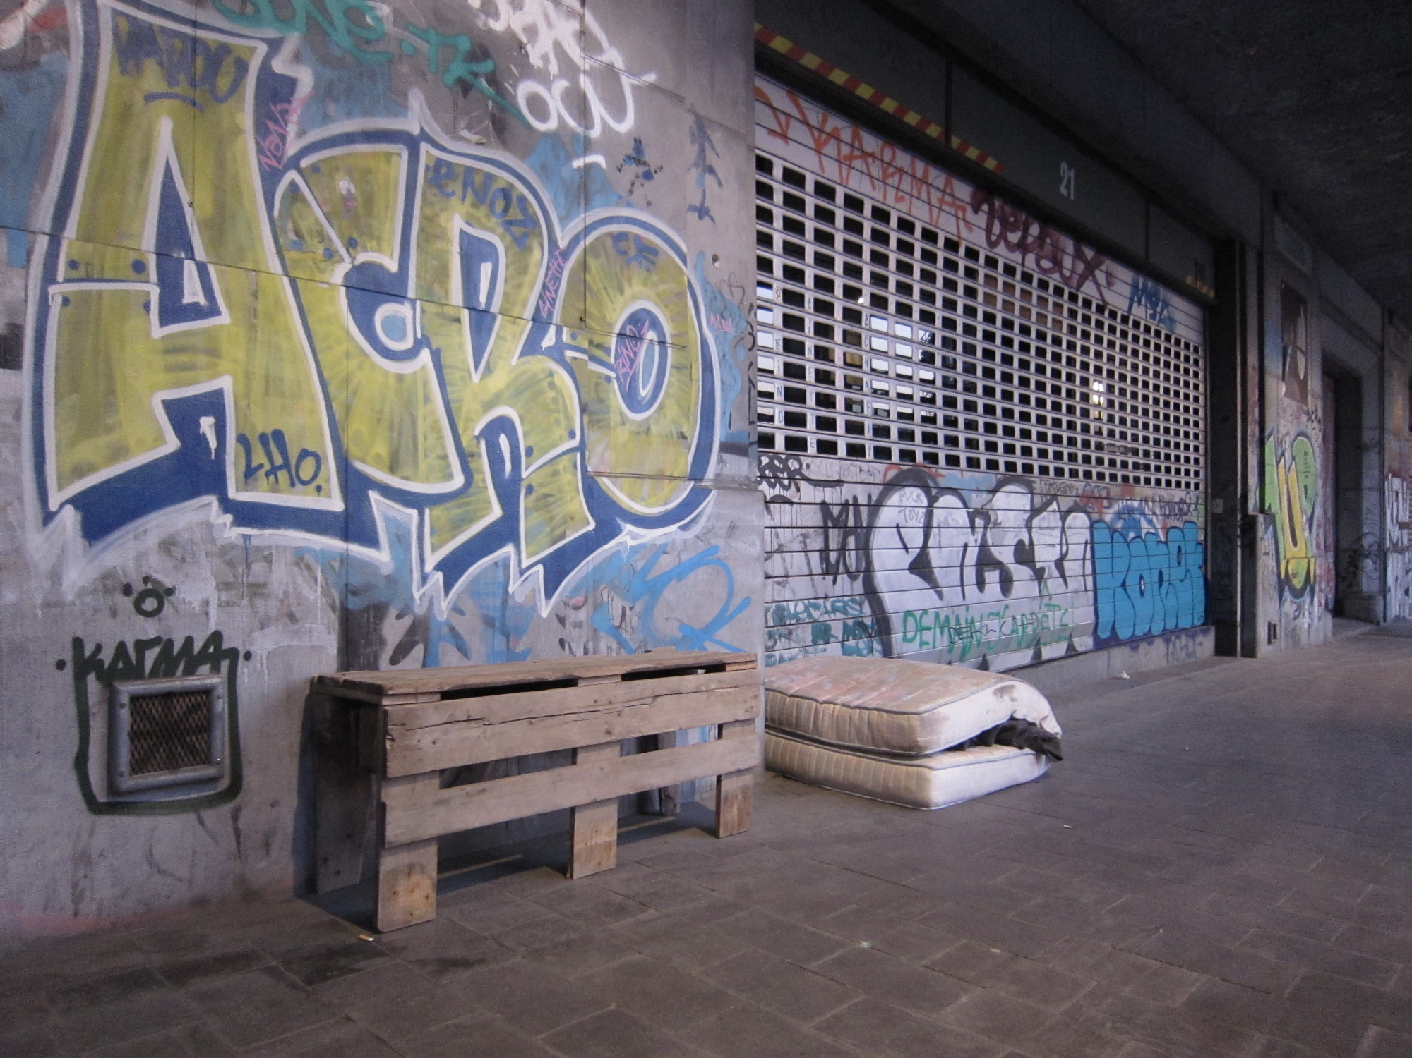
Material adicional: http://xuv.be/IMG/pdf/uh-bench.pdf
Se puede enviar una versión más detallada de la propuesta en un documento PDF (máximo 2 MB)

Documentación para la señalización de la expo:
En la exposición, cada propuesta va acompañada de una cartela en la que se detalla, a parte de sus autor@s, su receta de construcción. Es por ello que os pedimos:

Ingredientes *:
Lista de los materiales usados para la construcción de la propuesta
- 1 standard EPAL-EUR pallet
- 5cm nails

Herramientas *:
Lista de las herramientas necesarias
- Carpenter hammer
- Saw
- Crowbar

Preparación *:
Describe brevemente los pasos a seguir para la construcción y montaje de tu pieza
Follow the set of instructions given in the pdf that you can find here: http://xuv.be/IMG/pdf/uh-bench.pdf Roughly, you'll be making one saw cut next to the middle board of the pallet. You will then remove 2 or 3 boards. One will be cut to make the back legs of the bench. You will then reassemble all the pieces together. If you care, you can also reuse the nails from the pallet instead of using new ones.

