Journal
Time track of the Love Machine project.

2013

10/2013
+ Beginning refactoring the code and changing the framework. New script are based on phantomjs and casperjs. No more browser window in the way (headless) and it looks like a lot more easier to code. (So far, 39 lines to login and write a status.)

08/2013
+ Submission to Network(s) Art(s) Mobile Awards 2013. (Draft link)

04/2013
+ Quick presentation of the projet before the participants of Interactivos?'13, at Medialab Prado, Madrid. Many positive feedbacks.

2012

10/2012
+ (y) in a FB comment will be replaced by the icon of a like
+ Facebook announced it has 1.000.000.000 active accounts per month

07/2012
+ A spokesman for the social network said: “We don't see evidence of a 'wave of likes' coming from fake users or 'obsessive clickers'.” source
+ http://lovemachine.cc is the reserved domain name for this project

06/2012
+ The Want button appears in fbSDK.
+ FWB refused to give financial support.

05/2012
+ “When liking turns to loving” by Ronnie Dove (thx @autodespair)
+ Received a mail by Actiris (Unemployement Bureau in Belgium) inviting me to like their page
+ Attending Facesponge workshop and presenting [loveMachine]
+ lovemachine.cc (26€/y) or lovemachine.io (39€/y) still available at Gandi
+ Financial support asked at FWB.

01/2012
+ $('button[name=“like”]').trigger('click');
+ Thinking about a code rewrite, because of random bugs and ease of use.

2011

12/2011 :
+ Joined the fbresistance
+ Unlike Us
+ Just discovered that you can POST likes using the FB Graph API which raises a question… Should I use it? Should I use FB API for this or stay away from it?
+ Software submitted to Runme.org

11/2011 :
+ Pushed the code to Github https://github.com/juego/loveMachine
+ 99% ready for intl
+ @[288578057830204:0] makes a direct link to the page.
+ The bot liked this one:
+ Blog post
+ Creation of the Facebook Page [loveMachine] as an attempt to respond to the increase of questions regarding the numerous “likes” and strange status posts
+ Creation of the logo
+ Debugging
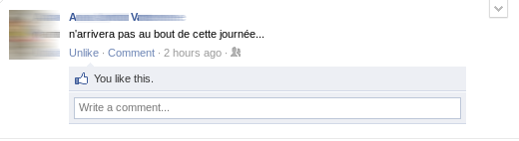 A.V. n'arrivera pas aubout de cette journée

10/2011 :
+ Code rewrite with Selenium 2 (Webdriver) and python

01/2011 :
+ First version of the script working with Selenium 1 IDE
+ Blog post

